Monitoring Type: Formal Monitoring

Night Survey #: 1 Outing #: 1 Survey Aborted? N Survey Completed? Y % Survey Area Covered: 100

Sunrise or Sunset Time: 1913

UTMs of New or Intermediate Call Points or Routes (not already mapped):
Call point name | UTME | UTMN |  | Call point name | UTME | UTMN
RIGGS3 | 596804 | 3620259
RIGGS2 | 597278 | 3619461
RIGGS1 | 596907 | 3618629
Moon phase: not visible
TIME (24hrs) | Start | End | Total (~ ¼ hr)

Hike-in
Survey | 1913 | 2020 | 1.0

Hike-out
CP or RT # | CM | SM | Time Start | Time End | Total Time | Moon visible? | Wind (mph) | CC % | PPT ? | Temp (◦F) | Obs. Type | Sex | Age | SPP | Time of response | Bearing  (◦) | Distance (m) | UTM E  of owl  (estimated) | UTM N  of owl  (estimated)
RIGGS1 | 2 | 2 | 1913 | 1928 | 15 | N | 0-2 | 100 | 0 | 54 | N
RIGGS2 | 2 | 2 | 1946 | 2001 | 15 | N | 0-5 | 100 | 0 | 52 | N
RIGGS3 | 2 | 2 | 2005 | 2020 | 15 | N | 5-10 | 100 | 0 | 56 | A | M | U | OTFL | 2011 | 233 | 90 | 596723 | 3620188
CM (Call Method): 1 = tape recording, 2 = vocalization, 3= combination, 4 = owl “hooter”; 5= not hooting SM (Survey Method): 1 = leap frog, 2 = point calling, 3=continuous calling; 4= not hooting Wind = range in mph; CC= cloud cover, PPT= precipitation (Y or N), Temp = ambient temperature; Obs. Type = aural (A), visual (V) detection, or put (N) for no response. SPP = 4 letter species code based on Latin name; Mex. Spotted Owl = STOC; Great Horned Owl = BUVI; Long-eared Owl = ASOT; Flammulated Owl = OTFL; Whiskered Screech Owl = OTTR; Western Screech Owl = OTKE; Elf Owl = MIWH; Northern Pygmy Owl = GLGN.

Brief Notes: WHIP-POOR-WILL CALLING NEAR RIGGS3 AT 2013 HRS – BEARING 207 DEGREES, APPROX 100 M, light rain earlier in evening

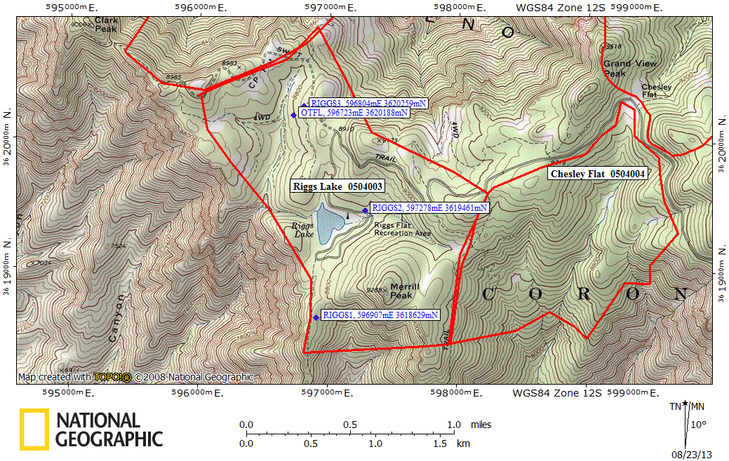

Red lines = PAC boundaries, waypoints = call points and owl locations

